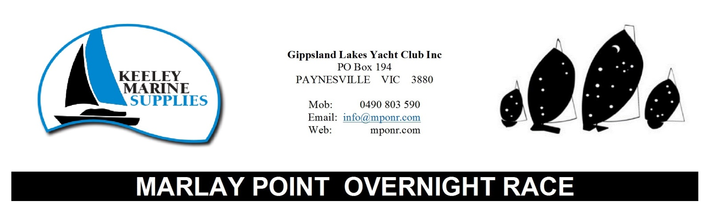
COMMODORE - Andrew Somerville www.sailglyc.com 0407 156 133
MPONR Phone 0490 803 590
Entry Secretary - Jenny Holter 0490 803 590
Entry Email entry@mponr.com
General Enquiry Email info@mponr.com

WELCOME
Gippsland Lakes Yacht Club (GLYC) in conjunction with Lake Wellington Yacht Club (LWYC) are proud to welcome you to the 52nd Marlay Point Overnight Race (MPONR). This year we welcome Latrobe Valley Yacht Club (LVYC), who after some trying years with the closure of Hazelwood pondage have joined in to help with this event.
Last year’s race saw 127 boats enter with two thirds completing the course. The race will be remembered by all for long spinnaker runs in the dark followed by trying to chase the faintest of puffs as the sun came up. Montague Point to the finish line in particular was a lucky dip of breeze.

Part of the Marlay magic is the surprise that awaits you on the far side of Lake Wellington, this is the first time since the start that you get any real gauge of how you are going. Sometimes it’s a happy surprise when you find yourself amongst much faster boats and other times you shake your head in disbelief when a much slower boat is leading the pack. That said the race isn’t just about the overall glory of winning your division. For most, it is the smaller battles against long time rivals that matters most. I am sure every crew has one boat that they aim to beat each year.

I would like to thank our major sponsor, Keeley Marine Supplies for their support and belief in our event along with our regular sponsors Bulls Cruisers; Cruising Helmsman; Captains Cove Waterfront Apartments, Bull Sails, Hill’s Marine and Leisure and Lightfoot’s Wines.

We would also like to thank the MPONR committee and all the volunteers who have
worked tirelessly to organise the event and the local communities and businesses who
support us. It is the on-water volunteers that I would also like to mention and thank. This year sees the three yacht clubs, GLYC, LWYC and LVYC take on all the on-water roles from the taxi service, to the fleet of support boats that follow us all night.

Remember to sail safely, enjoy being on the lakes and know you have achieved great
things competing in the race. We look forward to sharing your stories after you have
finished. I will see you at the presentation on Sunday as soon as possible after the last boat finishes.

Andrew Somerville, Commodore GLYC

Please don’t forget to hand in your declaration as soon as possible after finishing

RAFFLE
Books of five $2 tickets will be on sale at Marlay Point on race day. To secure your tickets early send us $10 or multiples thereof with your entry fee and collect your tickets on the day.
1st prize: Luxury Bulls Cruiser 3 nights
2nd prize: Captains Cove Waterfront Apartments, Max 6 people*, 3 bedrooms, 1 night
Hill’s Marine $100 voucher
3rd prize: Bulls Cruiser Day Boat Hire – 1 day
Cruising Helmsman Magazine 6 month subscription
Hill’s Marine $50 voucher
4th prize: Bull Sails voucher
Cruising Helmsman Magazine 6 month subscription
Hill’s Marine $50 vouchers
* Conditions apply

POLO SHIRTS
MPONR polo shirts can be ordered and paid for with your entry fee through the MPONR website until 29th February.
They will also be available from the Clubhouse on race day at $44 each. Availability on the day is limited and on a “first in best dressed” basis. Ladies sizes 8 to 18 and Men’s styles S to 4XL.
You can also order and pay for a shirt on race day for $49 and we will mail it to you after the event.

PAYNESVILLE BUS TRANSPORT
After launching on Saturday at Marlay Point, you may drive your car and trailer to Paynesville, and return by bus. Buses will leave Paynesville on Saturday from the King Street car park and GLYC at approximately l:30 pm and 4:00 pm. Bus tickets will be available from the bus driver at a cost of $20 each. Please note that the bus transport is only for Saturday. The last bus from Paynesville will return to Marlay Point after the sign on has closed. Signing on before taking your car and trailer to Paynesville is recommended.

ARRIVAL
Yachts arriving at Marlay Point by road should enter the large rigging area to the rear of the clubhouse via the IN gate on the Marlay Point Road. You may then launch in your own time. Immediately after launching, cars and trailers MUST leave the launch area and may return to the rigging area to park. Traffic flow to the launch area is one way. Cars must return to park through the IN gate.

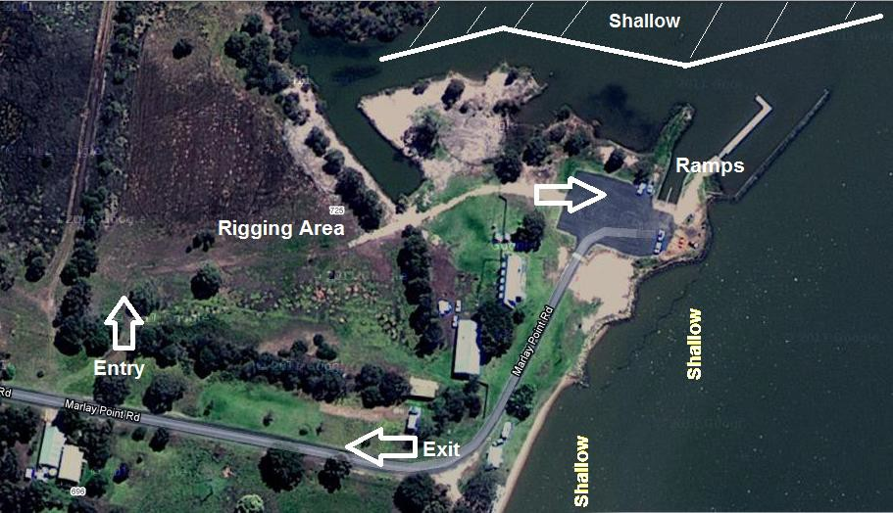
The Cut
Bunkhouse
In

SIGN-ON
A reception centre, SIGN ON desk, teams entries and Sailpass counter will be sited at the rear of the Clubhouse in the Bunkhouse. All skippers must confirm their entry in the race by signing-on before 4:30 pm on Saturday March 7th 2020.
You will not be accepted as a starter unless you have completed and confirmed the safety compliance declaration and on shore contact (next of kin) forms and submitted them to the sign- on official.
Sign on by radio is not available because of the need to submit the required forms.
*** NOTE ***
The last bus from Paynesville will not return you to Marlay Point in time to sign on so please sign on before leaving Marlay Point.

RACE INFORMATION
CONTACT INFORMATION DURING RACE
VHF: Ch 72
Phone: 0490 803 590
Email: info@mponr.com

The Lake Wellington Yacht Club will be manned from mid-afternoon on Friday and the Public Address system will operate all day on Saturday. Announcements may also be made on VHF channel 72 throughout the day. The GLYC will be open on Saturday until late on Sunday.

At GLYC general information will be displayed on the front door of the yacht club about the local area and the race. A race information centre will be sited at the GLYC and will be manned from early Sunday morning until all yachts have finished.

LAUNCHING RAMPS
A double ramp exists at Marlay Point suitable for yachts with a draught of 0.7m or less. Visitors are advised that there are extensive areas of shallows around the foreshore and care should be taken with lowering keels until at least l00m from the shoreline. Deeper draught yachts are advised to launch at the Port of Sale and motor down the Latrobe River into Lake Wellington. Masts should not be raised until yachts have passed under the Swing Bridge, approx. 3km from the Port of Sale. Launching facilities also exist at Hollands Landing (McLennan Straits), Loch Sport, Paynesville and Metung. The Cut is also very shallow and deeper draft boats will not be able to enter The Cut without becoming grounded.
IF NOT LAUNCHING AT MARLAY POINT ALLOW ENOUGH TIME TO GET THERE BY WATER AND TO GET ASHORE TO SIGN ON.

JETTY
The jetty adjacent to the launching ramps at Marlay Point must be left clear for access by official patrol boats. YACHTS MUST NOT TIE UP AT THE JETTY.

MOORINGS
Upon launching, all yachts are asked to moor clear of the ramp and jetty. Yachts requiring sheltered moorings are advised to moor in the Avon or Latrobe Rivers. Lake Wellington Yacht Club will not be responsible for vessels running aground or dragging anchors.

ON WATER SHUTTLE/WATER TAXI
A water taxi service will be available during Saturday. This will be manned by Latrobe Valley Yacht Club and as they are a small volunteer club, a small donation towards the cost of fuel would be appreciated for this service.

BUS TRANSPORT
After launching on Saturday at Marlay Point, you may drive your car and trailer to Paynesville and then return by bus. Buses will leave Paynesville on Saturday from the King Street car park and GLYC at approximately l:30 pm and 4:00 pm. Bus tickets will be available from the bus driver at a cost of $20 each. Please note that the bus transport is only for Saturday.
*** NOTE ***
The last bus from Paynesville will not return you to Marlay Point in time to sign on so please sign on before leaving Marlay Point.

PAYNESVILLE MAP:
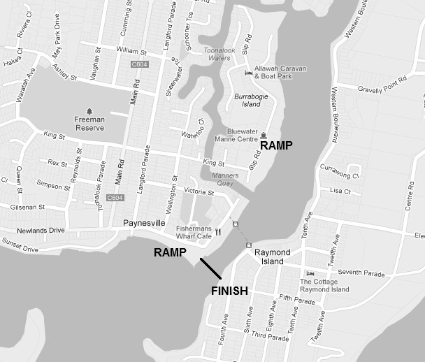
CARPARK
CARPARK
GLYC
WEATHER
Although every attempt will be made to provide up to date racecourse weather reports prior to the race, local weather effects on the Gippsland Lakes can be extremely difficult to predict even for professional forecasters. The weather is notoriously unpredictable and entrants must use their own discretion when deciding on whether to start or continue to race.

CATERING
There will be a large range of reasonably priced food and refreshments available at Marlay Point during Saturday. This includes breakfast through LWYC until 9am. Food vans will be selling water and soft drinks along with some scrumptious food. The Clubhouse will be open at Marlay Point on Friday evening and snack food may be available. Packaged beer will not be for sale. Please note that tap water at LWYC is not suitable for drinking.

Due to the nature of the race, the organising committee does not encourage consumption of alcohol on race day and reminds ALL competitors that the blood alcohol level for skippers is 0.05, the same as for road users and the Water Police are particularly active on the Lakes during this weekend.

At GLYC on Sunday, breakfast can be purchased at the club almost all day and there are several cafes in the vicinity of the club in Paynesville. GLYC bar will also be opened during Sunday from 12pm.

SAFETY INSPECTION
All boats on entering the race complete a Safety Declaration prior to the event. Safety inspections of competitors' vessels may take place at Marlay Point and Paynesville before and/or after the race.

All skippers and crews are reminded that the safety requirements are MANDATORY and failure to comply could result in disqualification. Skippers and crews are therefore requested to cooperate with the inspection teams to make the task as simple and pleasant as possible.

RESCUE CRAFT
On-water safety patrols will be coordinated by Gippsland Lakes Yacht Club who will utilise craft and personnel from their own organisation. These boats will show a blue light when on the water. The Water Police will be available via an emergency call to VHF Ch 16 or by ringing 000.

The purpose of the rescue craft is to provide an effective rescue service when required. They are not there for marshalling the race. If the weather conditions are kind, it is unlikely that you will even see a rescue boat throughout the race. Rescue craft are strategically positioned throughout the Lakes system during the race and will only be activated when directed by the on-course officials. They will have a blue lights signifying that they are a rescue craft.
Just a reminder that as a Cat 5N race, boats should be self-rescuing. Please see the Cat 5N safety declaration under race documents for more information.

Radio Frequencies being monitored throughout the race will be: VHF Channels 16 and 72.

All calls for assistance should initially be directed to the Emergency Channel 16 or by ringing 000.

PLEASE keep radio traffic to an absolute minimum.

REMINDER: Skippers and/or owners are reminded that all craft acting as rescue craft are instructed that in the event of a capsize, the people involved are the first priority for rescue. Salvage of disabled craft is not the responsibility of the rescue craft, but they may assist when the situation stabilizes.

FIRST AID
First aid assistance, provided by the St John Ambulance Service, is available at Marlay Point throughout Saturday.

POST RACE INFORMATION

SIGN-OFF DECLARATION
Race Headquarters will be in the Gippsland Lakes Yacht Club. Declaration sheets will be accepted at the information desk in the foyer of the GLYC.

FACILITIES GLYC
GLYC club has facilities available for all MPONR competitors. These include hot showers, toilets, food, the club bar, tea and coffee making facilities and race information.

PRESENTATION
We hope that you will all be able to join in on the Post-Race celebrations and Line Honours Presentations which will be held 6:00pm Sunday afternoon. This will include music, finger food and access to the bar. We ask you to respect the GLYC’s liquor licence and keep all alcohol within the confines of the club area.

CAR AND TRAILER PARKING FACILITIES
Ramps are available at the King Street car-park and the Esplanade west of the Club. Public toilets and showers are also available in these areas.

RESULTS
Printouts of provisional results may be posted in the GLYC clubhouse. Additional information may be obtained from the race information desk, this includes protest forms and result queries.

Final results will be posted as soon as possible on the MPONR website, www.MPONR.com and then emailed to all entrants as soon as possible thereafter.
For post-race information:
Check www.mponr.com or phone 0490 803 590

Emergency telephone numbers we hope you won’t need are:

AMBULANCE, POLICE or FIRE 000
WATER POLICE 5156 7462
DOCTOR 5156 7243
DENTIST 5152 4636
CHEMIST 5156 6671
HOSPITAL (Bairnsdale) 5150 3333
MARINE SALVAGE/DIVING 5156 6099
SHIPWRIGHT 5156 7085
SAILMAKER 5156 7039
AUSTRALIAN VOLUNTEER COAST GUARD 5156 0106

NOTE:
These numbers are all Bairnsdale or Paynesville numbers.

With thanks to our Sponsors

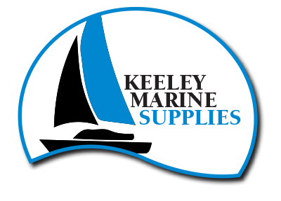

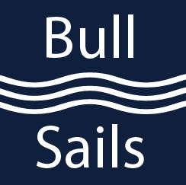
Product Sponsors

In kind sponsorship

…and to the following organisations for their continued and massive support: Clydebank Fire Brigade, the Water Police, the East Sale Bureau of Meteorology and St John’s Ambulance.

